**IMTIAZ AHMED**

**CONTROLLER USED**

A particular kind of feedback control system called a proportional-derivative (PD) controller combines proportional and derivative actions to improve system reactivity and stability. The proportionate element (Kp) applies a control effort that is exactly proportionate to the departure from the intended setpoint in response to the current mistake. This speeds up error reduction, but it may also cause oscillations and overshoot. In contrast, the derivative element (Kd) reduces oscillations and enhances system stability by forecasting future mistakes based on the rate of error change. The PD controller follows the equation,

whereas,

u(t)=control output,

e(t)=error signal,

Kp=proportional gain,

Kd=derivative gain,

(Hägglund and Åström (2006). A PD controller's ability to respond quickly and steadily is one of its main benefits; this makes it appropriate for applications like robotics, industrial automation, automotive control systems, and aerospace applications where accuracy and speed are crucial (Ogata, 2010). However, because it lacks an essential component and can be extremely susceptible to noise, particularly in real-world applications, a PD controller by itself is unable to eliminate steady-state error (Nise, 2019). Appropriate adjustment of Kp and Kd is essential for maintaining system performance balance since high-frequency noise can become unstable due to excessive derivative action (Dorf & Bishop, 2017). The PD controller is still a potent tool in control engineering, particularly when a quick and steady transient response is needed, despite its limitations.

Using the formula for settling time (2% criterion),

Finding the value of 𝜔𝑛 while maintaining the initial natural frequency value is as follows:

**𝜔𝑛 = 2𝜋𝑓**

𝜁

**Figure 1: Natural Frequency**

The provided simulation illustrates how a system would naturally react in the absence of a controller and how it would act in the event of an initial disturbance. As time passes, the oscillations in the yellow waveform gradually decrease, indicating the presence of damping in the system. About 12 cycles are completed by the system every second, with an oscillation frequency of 12.181 Hz. The oscillations' decreasing amplitude over time indicates that the system is steadily stabilizing on its own, although slowly. The length of time the waveform remains in the positive or negative zone during each oscillation is indicated by the duty cycle and pulse width shown in the right panel. The system settles using only its inherent damping because no controller is used, which results in a prolonged stabilization time. Such reactions are seen in real-world mechanical and electrical systems, such as motors, springs, and circuits, where excessive oscillations can impair functionality. By reducing oscillations more quickly, a proportional-derivative (PD) or proportional-integral-derivative (PID) controller could improve response time and system stability. The system could reach its goal state more quickly and smoothly while reducing unwanted vibrations by adjusting the proportional and derivative gains.

**Figure 2: PD Controller Parameters.**

**ACTUATOR USED:**

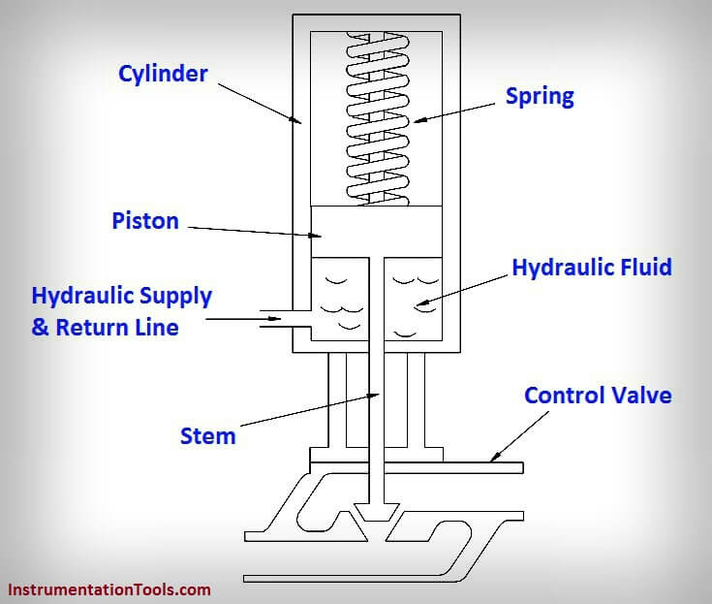

**Figure 3: Hydraulic Actuator Model.**

A mechanical device that transforms hydraulic energy, or fluid pressure, into mechanical motion is called a hydraulic actuator. Robotics, industrial machines, aeronautical systems, and heavy-duty applications requiring tremendous force and accuracy all make extensive use of it.

**RESULTS:**



**Figure 4: Vibration Control Simulink Setup**

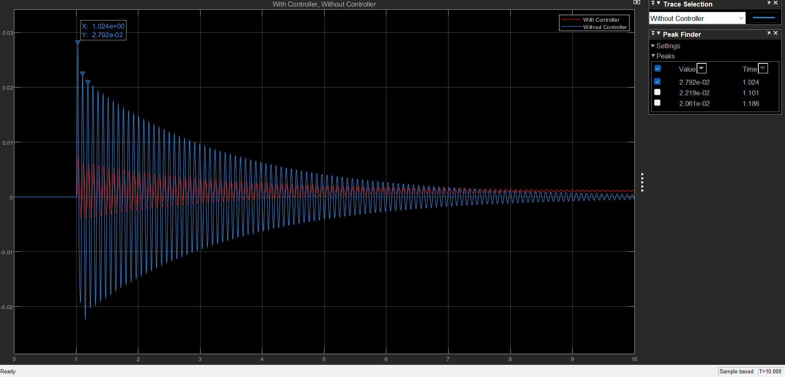

**Figure 5: Peak-Without Controller.**

The provided simulation contrasts the system's response with and without a controller; the response with a controller is represented by the red waveform, while the response without a controller is represented by the blue waveform. The uncontrolled system's peaks (blue waveform), which show how the system oscillates in the absence of a control mechanism, are the focus here. The oscillations' greatest values are displayed by the Peak Finder tool; the first peak appears at Y = 0.02792 (or 2.792e-02) at X = 1.024 seconds. Later peaks, as Y = 0.02219 at X = 1.101 seconds, show a slow amplitude drop, indicating that the system is gradually damping.

The system uses only its inherent dampening properties to lessen oscillations because there is no controller. In real-world applications where accurate and fast responses are needed, such as industrial automation, robotics, or motor control, this might lead to slower stabilization and higher initial peaks (Ogata, 2010). On the other hand, the red waveform (with a controller) shows a quicker oscillation decay, indicating that the controller enhances stability by more effectively lowering peak amplitudes. By modifying the system's behaviour to reduce excessive oscillations and enable it to settle more quickly, a proportional-derivative (PD) or proportional-integral-derivative (PID) controller would be helpful (Nise, 2019). The significance of controllers in maximizing system performance and minimizing undesired oscillatory behaviour is demonstrated by this simulation.

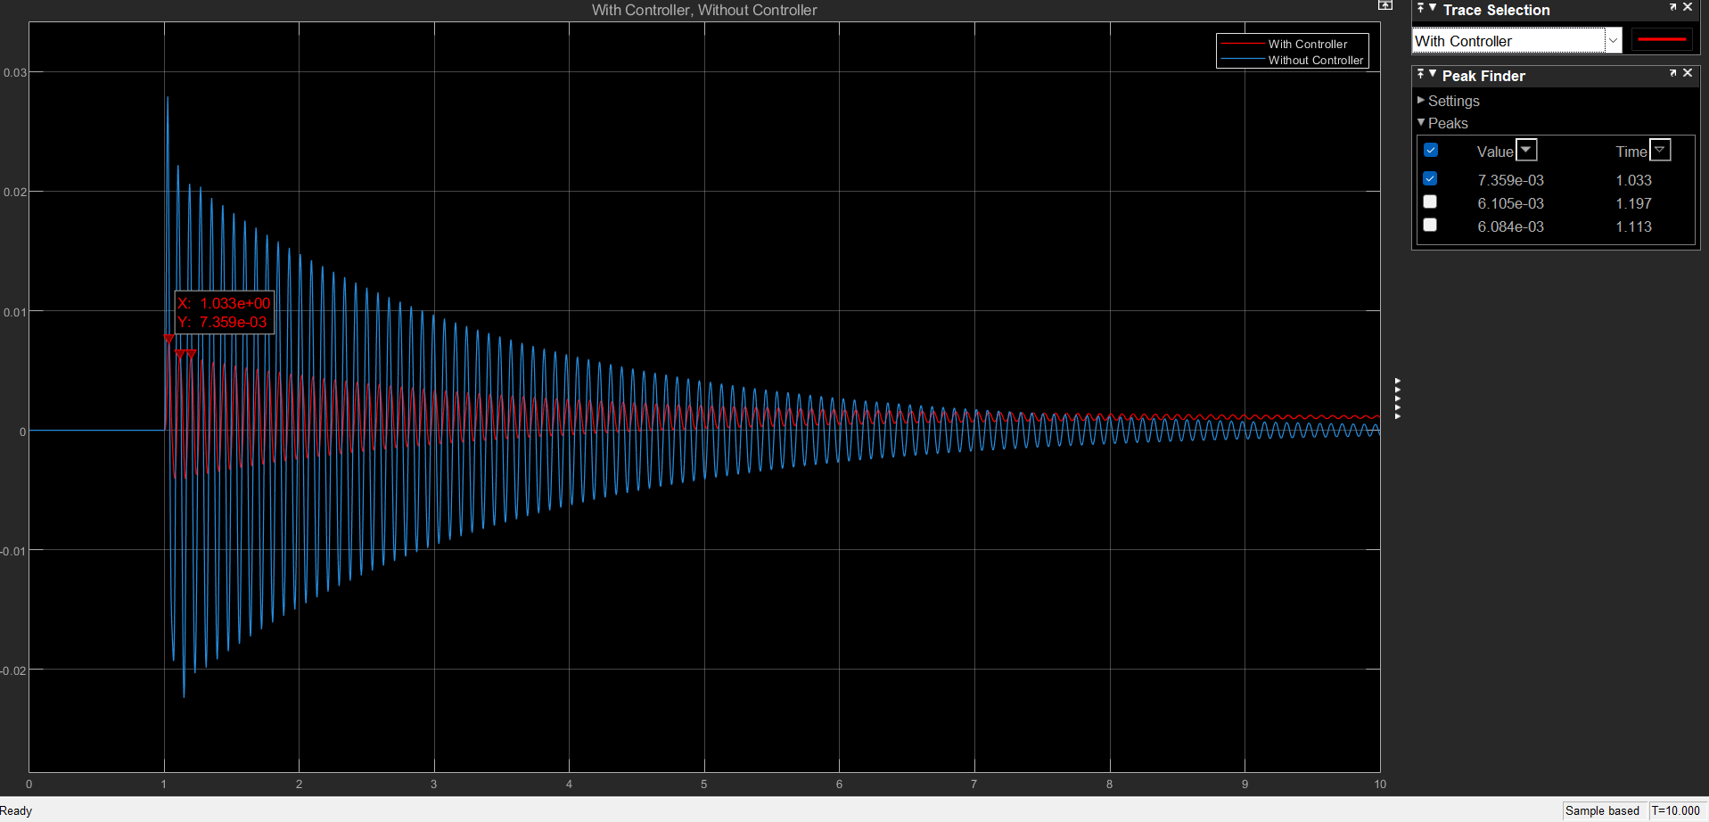

**Figure 6: Peak-With Controller**

The oscillatory behaviour of the system is compared in this simulation with and without a controller. The response with a controller is represented by the red waveform, and the uncontrolled reaction is represented by the blue waveform. Key peak values for the regulated system are identified by the Peak Finder tool. Y = 0.007359 (or 7.359e-03) at X = 1.033 seconds is the first peak to occur, and Y = 0.006105 at X = 1.197 seconds is the second peak.

The peak amplitude is much lower than in the prior simulation (without a controller), indicating that the controller successfully reduces excessive oscillations. Furthermore, the oscillation decay rate is larger, indicating that the system stabilizes more quickly than the uncontrolled system. According to Ogata (2010), this behaviour implies that the controller, which is probably a proportional-derivative (PD) or proportional-integral-derivative (PID) controller, modifies the system response to lessen overshoot and guarantee faster oscillation damping. Additionally, the controlled system transitions to steady-state conditions more smoothly and gradually, which makes it perfect for real-world applications such as industrial automation, robotic arms, and servo motors (Nise, 2019).

The efficiency of the controller in enhancing system performance and stability is demonstrated by contrasting this with the uncontrolled system, where the oscillations last longer. Optimizing response time while reducing mistakes and oscillations is a key objective in control systems engineering (Dorf & Bishop, 2017).

**Figure 7: Settling time-Without Controller.**

The blue waveform in the simulation represents the settling time of a system without a controller. According to the measurement instrument, it takes the system about 8.994 seconds to stabilize and experience few oscillations. Longer oscillations with a larger peak amplitude in the absence of a controller are indicative of inadequate damping in the system. The system's inability to efficiently waste energy results in prolonged oscillations before stabilizing, which causes this prolonged settling time. Furthermore, the uncontrolled system is less appropriate for precision-based applications due to its increased overshoot. The system's oscillatory nature and inadequate damping are further highlighted by the frequency measurement of 111.184 mHz. System performance suffers because of the response's prolonged instability in the absence of a controller. On the other hand, by implementing suitable damping, a controlled system, such one that uses a PID (Proportional-Integral-Derivative) controller, can drastically cut down on settling time, eliminate overshoot, and enhance system stability (Ogata, 2010). By improving both transient and steady-state behaviour, control techniques maximize system reactivity and guarantee quicker convergence to a desired state (Dorf & Bishop, 2017; Nise, 2019).

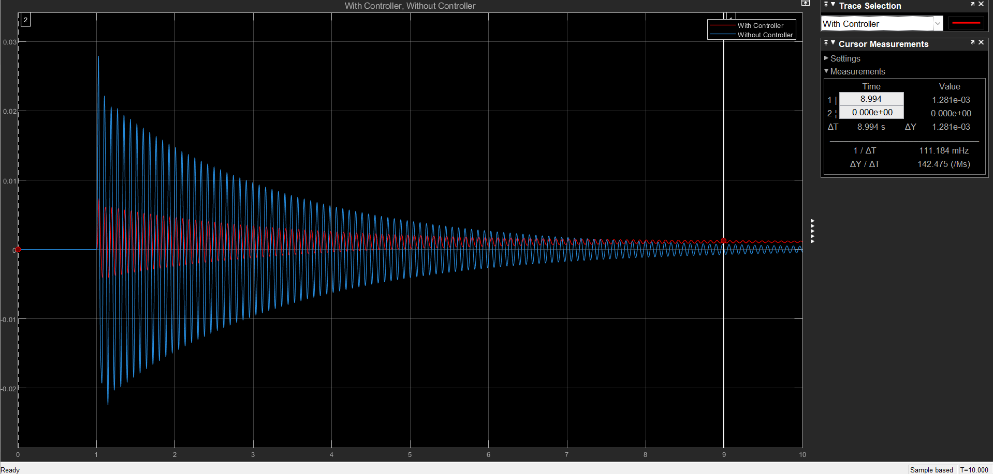

**Figure 8: Settling time-With Controller.**

The simulation highlights how control mechanisms affect settling time by showing the system's response both with and without a controller. The system reaction in the absence of a controller is represented by the blue waveform, which has longer oscillations and a larger amplitude. The reaction with a controller is represented by the red waveform, which has a smaller amplitude and faster damping, demonstrating how well the controller reduces oscillations and enhances system stability. According to the cursor measurements, the system with the controller exhibits better transient response, with a settling time that is noticeably shorter than the system without control.

By modifying system parameters to lessen overshoot and settling time, a controller typically a proportional-integral-derivative (PID) or lead-lag compensator improves stability (Ogata, 2010). The system reaches the intended steady-state condition faster and with less variance when feedback control is included. The decrease in oscillations implies that the system improves its damping properties, reducing the likelihood of prolonged oscillations.

The enhanced reaction, which more effectively mitigates disturbances and speeds up stabilization, demonstrates the controller's efficacy. This improvement is essential for applications including industrial automation, robotics, and power systems that demand accuracy and stability (Nise, 2020). The need for control techniques to maximize dynamic performance in engineering systems is highlighted by the comparison of the two responses.

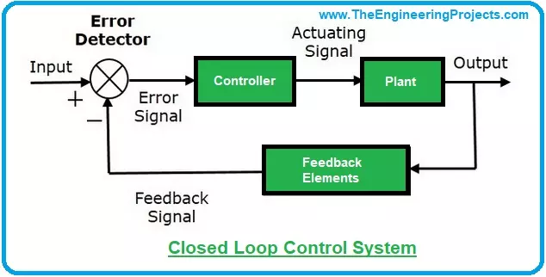

**Figure 9: Control System Setup.**

**DISCUSSION:**

**Figure 10: Results Comparison.**

The substantial influence of control mechanisms on system performance and stability is demonstrated by the comparison of the system response with and without a controller. The blue curve, which represents the uncontrolled system, shows bigger oscillations with a higher amplitude and a slower decay rate, which results in a longer settling period. This suggests that it takes longer for the system to stabilize. On the other hand, the red curve indicates the controlled system, which has a faster settling time, a smaller amplitude, and a noticeable decrease in oscillations. By limiting undesired oscillations, lowering peak deviations, and increasing damping characteristics, the use of a controller improves system stability. This implies that a more steady response is ensured and that the controller, which is probably a proportional-integral-derivative (PID) controller, successfully adjusts for disturbances. The regulated system's enhanced transient performance demonstrates how well it works to reach a faster and more stable steady-state. As a result, adding a controller greatly enhances system behaviour and qualifies it for real-world uses where response time and stability are crucial.

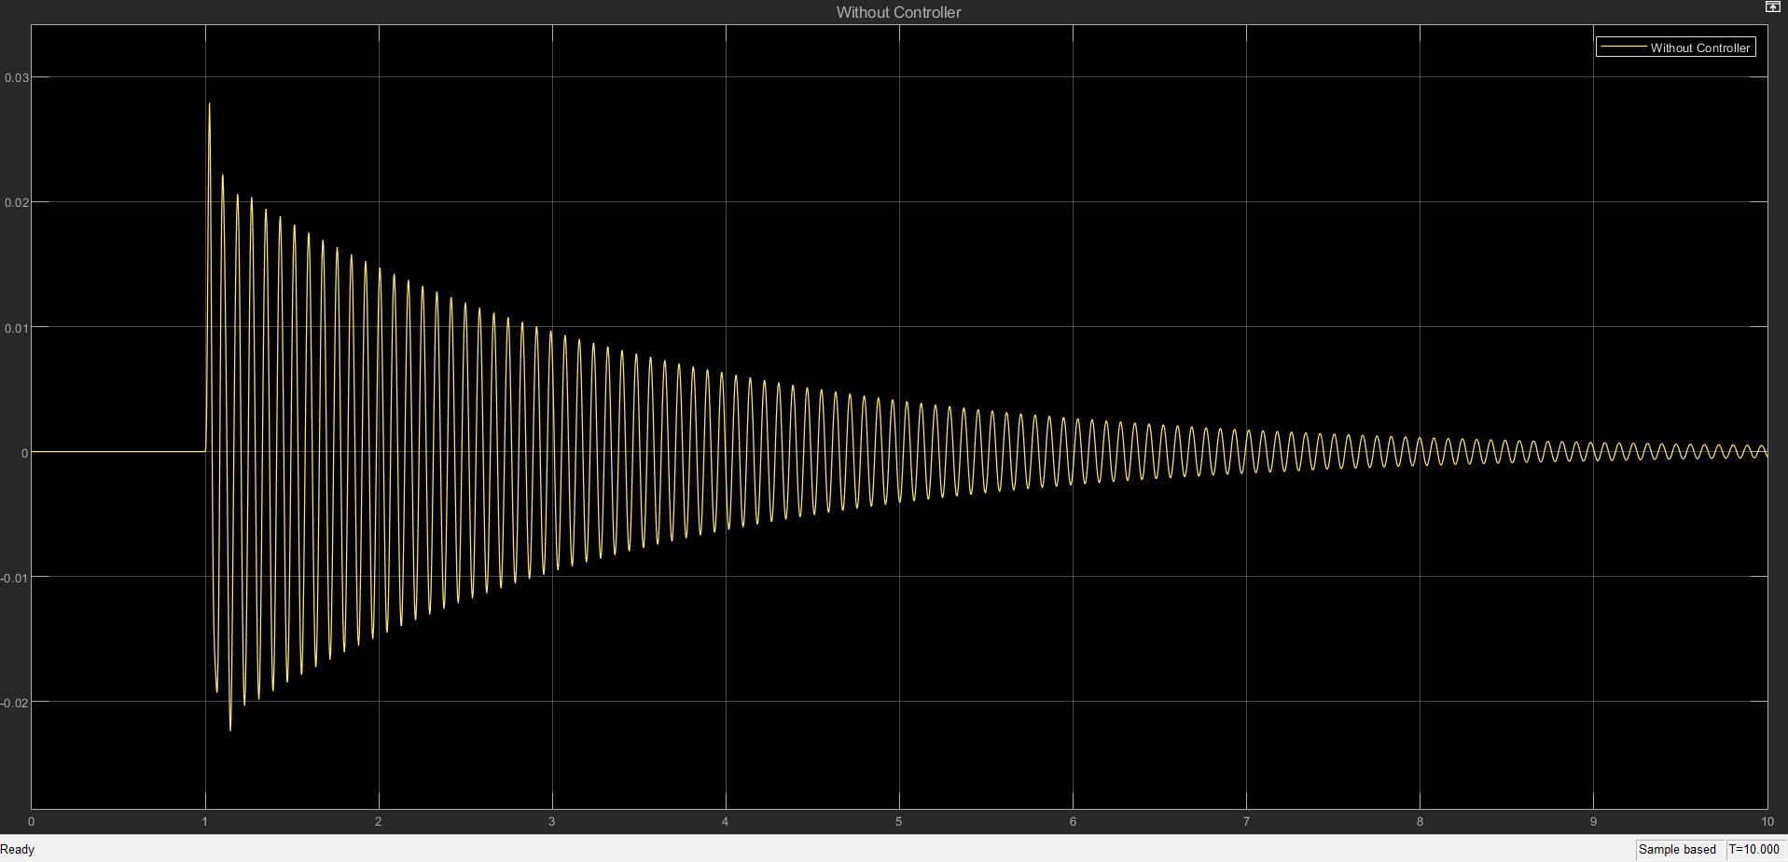

**Figure 11: Results without Controller**.

Without a controller, the simulation results demonstrate the system's intrinsic instability and long settling time. The graphic illustrates the response's notable oscillations, which have a sluggish decay rate and a large amplitude. This suggests that the system is more prone to external perturbations since it takes longer to stabilize. The damping effect is insufficient without a controller, resulting in persistent oscillatory behaviour. Underdamped systems, where natural frequency predominates because compensatory control mechanisms are absent, exhibit this kind of reaction. In real-world applications where quick stabilization is necessary, the sluggish attenuation of oscillations may indicate subpar transient performance. The uncontrolled system is unable to attain a desired level of stability in an acceptable amount of time, in contrast to a controlled system that optimizes reaction characteristics. To improve system stability, decrease oscillations, and achieve a quicker settling time all of which lead to better performance in practical applications a controller must be included.

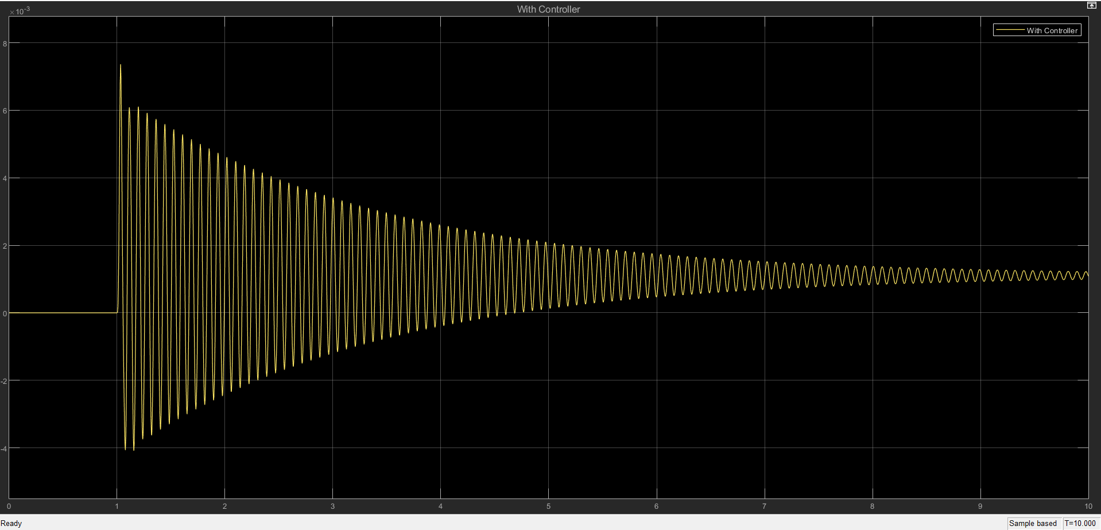

**Figure 12: Results with Controller.**

When compared to the uncontrolled response, the simulation results show a notable improvement in system stability when using the controller. When the controller is present, the response's amplitude is significantly reduced, suggesting fewer oscillations. Furthermore, the system stabilizes faster than the uncontrolled system due to its faster settling time. This enhancement results from the controller's capacity to apply damping, which successfully reduces oscillatory behaviour and overshoot. By lowering instability and guaranteeing that the system runs within reasonable performance bounds, the controller's existence leads to a more effective transient response. The controller improves overall performance by actively controlling system behaviour, increasing the system's resistance to outside disruptions and enhancing dependability in real-world applications. The controlled response amply illustrates the benefits of using a feedback mechanism to manage system dynamics, in contrast to the uncontrolled system, where oscillations last for a long time.



**Figure 13: Criteria for Vibration Limits.**

**LIMITATIONS:**

However, no solution is flawless, and using this controller has disadvantages as well. For example, the vibration levels are still too high for hospital sensitive equipment (Jayawardana et al., 2018), and doctors advise against being close to pregnant women's homes because it may harm the fetus's development (Siwula et al., 2011).

The hydraulic actuator's integrator action causes the vibration levels to drift or offset steadily over time rather than settle at zero, which is another significant drawback of this configuration. This offset happens because of the integrator's constant accumulation of tiny mistakes or disturbances, which causes residual vibrations to continue after the transitory reaction has subsided. Even while these residual vibrations are less than the initial levels, they can nevertheless cause issues in settings like precision labs or industrial setups that need precise alignment where total vibration reduction is essential. Furthermore, the prolonged offset may shorten the operational lifespan of adjacent machinery or buildings by aggravating wear and tear.

**FURTHER IMPROVEMENT**

A feedforward control in conjunction with feedback can enhance performance by adjusting for predictable disturbances, which is the first step in addressing the constraints of the vibration control system. Second, incorporating a sensor into the feedback loop such as a velocity transducer or accelerometer can help with adaptive control, guaranteeing that the system reacts appropriately to outside disturbances that the model might not fully take into consideration. Lastly, a dual-actuator configuration can be used, in which the two actuators cooperate to control the vibration levels and reduce the offset brought on by the integrator.

**REFERENCES:**

1. Åström, K. J., & Hägglund, T. (2006). Advanced PID control. ISA – The Instrumentation, Systems, and Automation Society. <https://www.isa.org>
2. Ogata, K. (2010). Modern control engineering (5th ed.). Pearson. <https://www.pearson.com>
3. Nise, N. S. (2019). Control systems engineering (8th ed.). Wiley. <https://www.wiley.com>
4. Dorf, R. C., & Bishop, R. H. (2017). Modern control systems (13th ed.). Pearson. <https://www.pearson.com>
5. Esposito, A. (2020). Fluid power with applications (7th ed.). Pearson. <https://www.pearson.com>
6. Merritt, H. E. (1967). Hydraulic control systems. Wiley. <https://www.wiley.com>
7. Parr, A. (2011). Hydraulics and pneumatics: A technician’s and engineer’s guide (3rd ed.). Butterworth-Heinemann. <https://www.elsevier.com>